**Capstone Project**

**Problem Statement:** A small company Axon, which is a retailer selling classic cars, is facing issues in managing and analyzing their sales data. The sales team is struggling to make sense of the data and they do not have a centralized system to manage and analyze the data. The management is unable to get accurate and up-to-date sales reports, which is affecting the decision-making process.

**Aim:** The goal of the capstone project is to design and implement a BI solution using PowerBI and SQL that can help the company manage and analyze their sales data effectively. The action plan includes the following:

1. Import and integrate the data from MySQL database into PowerBI.
2. Clean and transform the data to make it ready for analysis.
3. Build interactive dashboards and reports using PowerBI that can help the sales team and management make sense of the data.
4. Use SQL to perform advanced analytics on the data and extract insights that can help the company improve its sales.
5. Enable the management to access the dashboards and reports in real-time and make data-driven decisions.

**About Dataset:** The dataset contains business data from 06/01/2003 until 31/05/2005. It consists of 8 tables and a brief description of these table are:

Customers: stores customer’s data.

Products: stores a list of scale model cars.

ProductLines: stores a list of product line categories.

Orders: stores sales orders placed by customers.

OrderDetails: stores sales order line items for each sales order.

Payments: stores payments made by customers based on their accounts.

Employees: stores all employee information as well as the organization structure such as who reports to whom.

Offices: stores sales office data

**Steps for Analysis**

1. Data Extraction: Created a new database in MySQL and used it as a data source to load data in PowerBI.
2. Data Transformation: Performed cleaning of data by using Power Query Editor. It included removing duplicates, rectifying datatype, removing null rows and ensuring data consistency. The cleaned data was loaded to Power BI desktop.
3. Data Modelling: Managed the different table relationships and created two additional tables as Dim Date and Calculations for using Date Intelligence feature and calculating measures.
4. Preparing Report: Used different types of visualizations to create dashboards with useful insights and information for the management. Link for the dashboard- <https://www.novypro.com/project/sales-dashboard-109>
5. Advanced Analysis: Used MySQL to perform further analysis using the dataset.
   * **Date range**



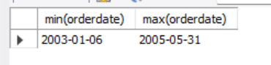

The dataset contains data starting from 06/01/2003 to 31/05/2005.

* **Total orders monthwise**

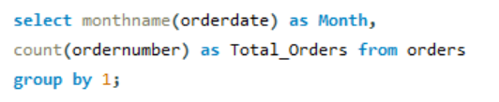

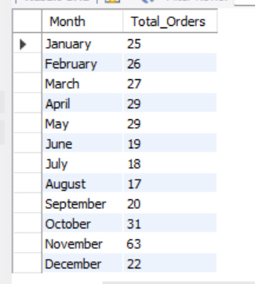

It can be observed that the sales is highest in the month of November and is constant towards rest other months.

* + **Total Sales by Status**

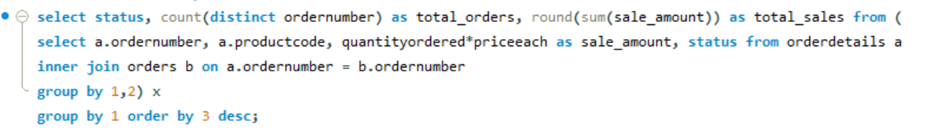

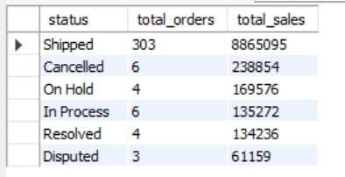

* + **Total shipped orders vs failed orders**

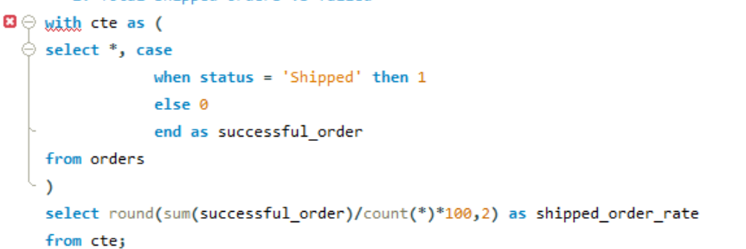

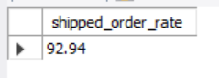

We can see that around 93% of the orders are shipped successfully to the customers.

* + **Total Sales by year**

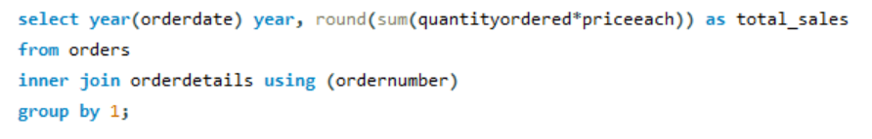

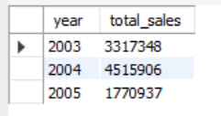

It can be observed that the total sales was highest in the year of 2004 and for 2005 the data is present upto the month of May.

* + **Total Orders and Sales for each productLine**

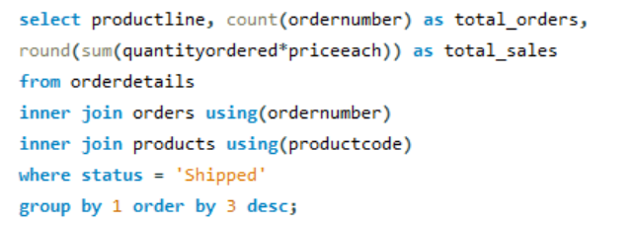

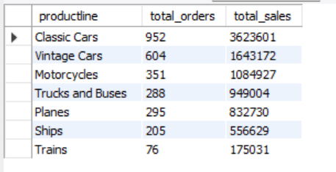

It can be seen that the product line of Classic and Vintage Cars covers around 60% of the total orders. The product line of Trains has the lowest number of orders over the 3 years.

* + **Total Orders and Total Sales for each productline yearwise and overall**

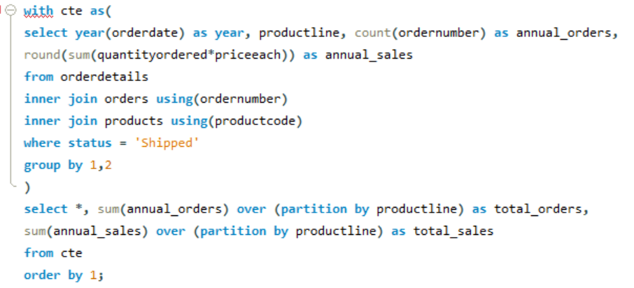

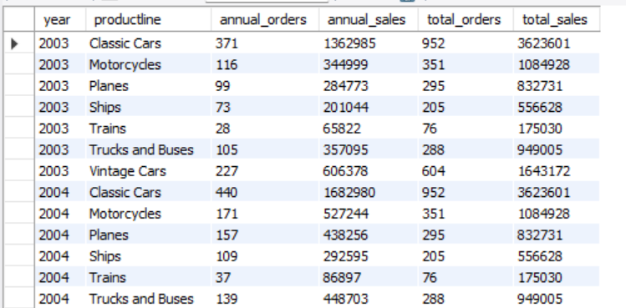

* + **Unique Customer transactions per year**

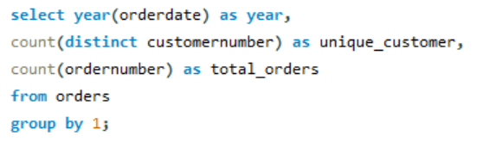

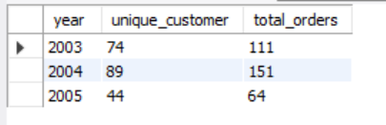

We observed that in year 2003, out of the 111 total orders, there were 74 unique customers and also in year 2004, there were 89 unique customers for 151 orders. In year 2005, there are 44 unique customers for 64 total orders.

* + **New customers over the years**

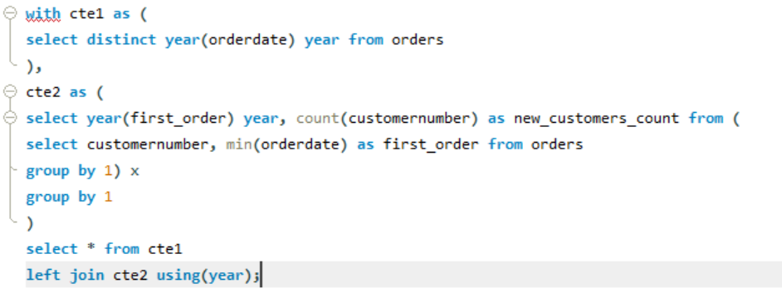

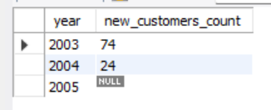

The growth of new customers for each year is decreasing. We observed that there were 74 new customers in 2003 and 24 new customers were added in 2004. It gets extreme in 2005 that no new customer has been added until the month of May.

1. Insights: A detailed report was prepared by mentioning all the insights from the dataset.
2. 2004 had the highest total Sum of Profit at $1.81 Millions, followed by 2003 at 1.32 Millions and 2005 at 0.69 Million.
3. At $3.85 Millions, Classic Cars had the highest sum of Sales and was 1,944% higher than Trains, which had the lowest sum of Sales at $18.8 Millions.﻿ Classic Cars accounted for around 40% of Total Sales.﻿﻿
4. It can be seen that the product line of Classic and Vintage Cars covers around 62% of the total orders. The product line of Trains has the lowest number of orders over the 3 years.
5. In both 2003 and 2005, November month had the highest sales which has resulted in highest profits. Whereas in rest of the months the sales has been constant.
6. Among all the Countries, the company has made the highest sales from the customers in USA.
7. The average order value stands at around 29.5k Dollars. The Order Value of ﻿﻿20k-40k had the highest orders at 135, followed by <20k, 40k-50k, and >50k.﻿﻿
8. Almost 93% of the orders has been shipped successfully to the customers. It takes around 3.6 days on an average to ship an order after it has been placed.
9. It seems that the growth by quarter (QoQ%) has been negative in the 1st quarter for all the years(-55 & -48%). This negative growth is attributed to the higher growth of sales in the 4th quarter of each year.
10. It was found that 2001 Ferrari Enzo has received the highest orders and 1952 Alpine Renault 1300 is the most profitable product among all.